Welsh castles relay 2022 (the bus drivers perspective) Welsh castles relay, Caernarfon castle to Cardiff Cardiff run over 2 days following a route down through the middle of Wales. 200 miles, 20 stages, 58 teams. It had been many years since Swansea had entered and open Team and 20 years since they last won it. In fact it hadn’t been won by a welsh team in ten years being dominated by strong English Clubs. This year we aimed to set that straight! The Team had been selected and despite a few unfortunate last minute changes confidence was high. The early stage runners set off for Caernarfon on Friday afternoon in readiness for the 10.00am start on Saturday. The rest off the team would follow over the weekend to their respective starts as the race progressed down the country.
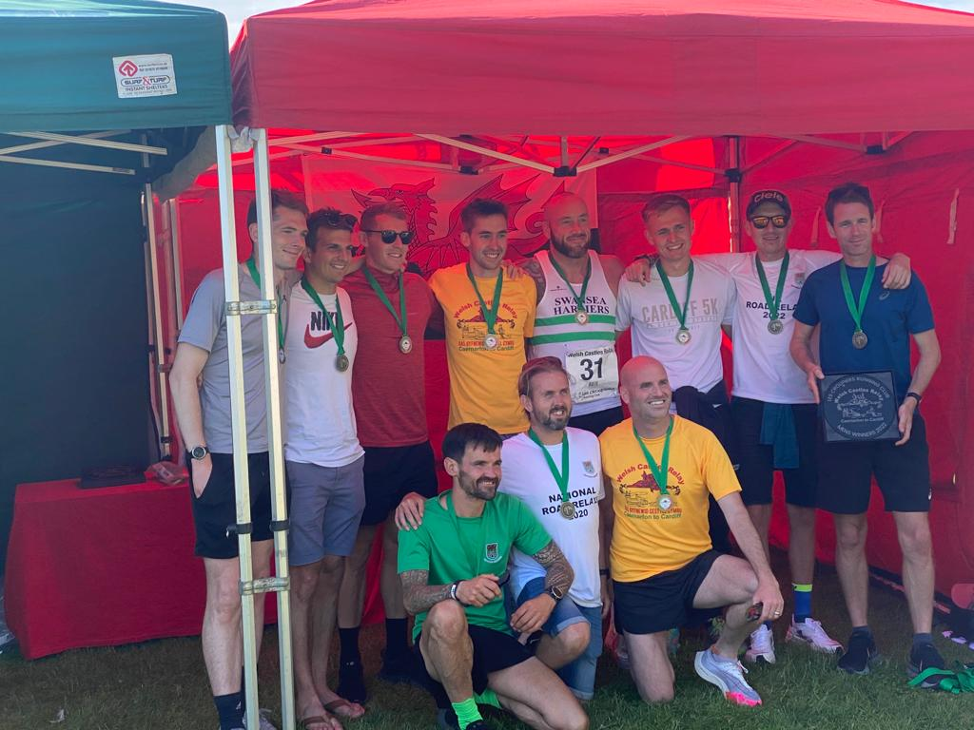
The honour of leading the team out on the first stage fell to Sam Joseph and after a pre start mad dash by all team busses to get their runners to the opposite side of the river after the council removed the footbridge that was supposed to form part of the course, the weekend began. Stage 1 Caernarfon to Penygroes 9.1 miles. Sam puts in a really strong performance into a ferocious headwind wind for most of the stage to finish 6. 4 mins behind WCR newcomers Kent who set a new stage record.
Stage 2 Penygroes to Criccieth 10.7 miles. Matthew Harvey is up next and runs a great stage missing out on second by 4 seconds in downhill Sprint into Criccith. Chorlton take the win but its local rivals Pontypridd roadent that top the table with Swansea in second.
Stage 3 Criccieth to Maentwrog, 12.3 miles The first of the mountain stages and the word was out. Dewi Griffiths was running this one! Smashing the stage to take the victory by well over a minute and breaking Martin Rees’s 25 year old stage record. More importantly Swansea now topped the table.
Stage 4 Maentwrog to Harlech castle. 9.5 miles the rest of the team start to arrive for the Saturday stages and its Matt Verran’s turn who again runs a great stage finishing 3rd and putting over two minutes on the Pontypridd runner. Its becoming a two horse race as Swansea and Pontypridd start to pull clear of the rest of the teams
Stage 5 Harlech to Barmouth. 9.6 miles Paul Tobin is up for stage 5 and takes the stage win by over 1 and a half minutes and the coveted stage winners t shirt. Pontypridd are hanging in there in second however.
Stage 6 Barmouth to Dolgellau. 9.1 miles Guy Smith next who gives everything finishing second and taking more time off our rivals.
Stage 7 Dolgellau to Dinas Mawddwy. 10.1 miles Jon Butlers turn and another superb run. Second place by 15 seconds in a time that would have smashed the old stage record by 2 minutes and more importantly puts 3.5 minutes on Pontypridd. The lead is out to five minutes and the group chat is in overdrive as everyone rushes to support runners on each of the stages, racing ahead to catch others pre start and congratulate at the finish, But theres a problem Jack Gooch is injured and won’t be able to run tomorrow. Marc has his work cutout to pull in a replacement.
Stage 8 Dinas Mawddwy to Foel The only stage support teams aren’t allowed to stop and support so its Over to Finley Hines. Leading from the start its another stage win, new stage record and another 3.5 minutes on our rivals. A gap is starting to open up.
Stage 9 Foel to Caereinion 8.5 miles another stage win as Dan Newton puts in a superb effort but its Ponty in second 7 seconds behind.

Stage 10 LLanfair to Newtown 13.1 miles a hilly half marathon to finish day one as Blair McWhirter runs solid performance to come in fourth, But Pontypridd take the win and a new stage record to claw back valuable minutes.

Off to Llandrindod for the night and after food and the obligatory analysis, time to rest. Day 2 7.00am start at Newtown for stage 11 Newtown to Llanbadarn Fynydd. 10.8 miles Only one man for the job at that time in the morning and Geraint Williams doesn’t Disappoint. A great run into fourth right on the heels of the Pontypridd man.
Stage 12 LLanbadarn Fynydd to Crossgates. 11.2 miles Richard(I can’t remember last time I ran that far) Copp is nervous pre start. He needn’t have been, runs a superb race finishing third and again holding on to our rivals.
Stage 13 Crossgates to Builth wells the first of the runners to travel up on the Sunday is Andrew Cleverly. Running from the front for large parts eventually finishing third and 20 seconds ahead of Pontypridd. The overall lead is holding and the team is growing as everyone is focussing on supporting their teammate.
Stage 14 Builth Wells to Drovers arms 10.8 miles The infamous Drovers stage awaits Marc Hobbs who puts in a true Captains performance on the brutal hill climb and goes to a very dark place to haul himself to within 1 second of Pontypridd in an epic sprint finish.
Stage 15 Epynt Centre to Brecon 12.8 miles Jack Turner is up and its another great run into third place over 1 minute ahead of Pontypridd. Its still close but belief is growing it could happen.
Stage 16 Brecon Canal Basin to Torpantau 12.5 miles Another king of the mountain stage and its Ben Williams who runs another strong stage despite carrying an injury. But its Pontypridd win the stage and take 5 mins out of the lead.
Stage 17 Torpantau to Merthyr8.7 miles By now the mid Wales traffic and mobile signal are putting a huge strain on logistics and we miss catching Dominic smith at his start, but the official confirm he was there and did start. Off in pursuit we head to stage 18 and await reports. The constant stream of updates is relentless with Matt Verran doing some outstanding work with his videos.
Stage 18 Merthyr to Quakers yard. 9.1 miles its feel like the finish is in sight now and we are still holding a lead. Matt Richards heads out on Stage 18 to finish fourth but Ponty claw back a little time.

Stage 19 Abercynon to Nantgarw 7.7 miles the lead is 6 minutes with two stages to go and Steve Taylor has been called in the week before as replacement. Showing his strength of character he finishes second in the stage but its nearly 3 minutes behind the winner, from Pontypridd!
Stage 20 Caerphilly castle to Cardiff castle 10.1 miles Stand up Danny Otterson! Answered the call at the very last minute and tasked with protecting a 3 and a half minute lead after nearly 20 hours of racing to win the Welsh castles relay he was understandably nervous. Marshalling duties is an obligation for each team at some point during the weekend and we had to supply two for stage 20. Marc Hobbs and myself duly obliged and hence were cut off from the action. Danny went through our marshalling station at three miles 1 minute behind Pontypridd, it was going to be tight. Our marshalling duties fulfilled we headed for the finish, then confusing reports, Danny had passed but no sign of Pontypridd! Then the news broke, the Pontypridd runner had given everything trying to make up the deficit and collapsed before the finish. Thankfully marshals and paramedics attended and he recovered and was seen at the prize giving later. Danny Pushed on to finish 9 and secure the Victory. And that’s the short version! An amazing weekend that encompasses everything that is great about our sport. 2022 Welsh Castles relay Champions. 200 miles, 20 phenomenal athletes, 1 incredible team!! Till next time!

