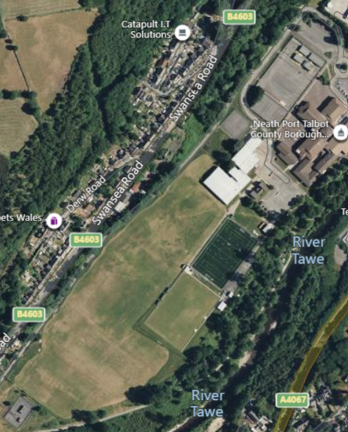
Coaches parking
Red arrows = 1 x 1100m Lap
Yellow arrow = changeover zone
Blue arrow = finish line for last/3rd leg runner

Car & Minibus parking
Registration & Toilets
TIMETABLE
1.00pm Year 7 Girls/Boys 3x1100m 3300m
1.20pm Year 8/9 Girls/ Boys 3x1100m 3300m
1.40pm Year 10/11/12/13/14 Girls/Boys 3x1100m 3300m

SCHOOLS & COLLEGES
St JOSEPH’S BAE BAGLAN BISHOPSTON BISHOP VAUGHAN CWM BROMBIL
BISHOPGORE OLCHFA CEFN SAESON LLANGATWG BRO DUR
PENYRHEOL GWYR DWR-Y-FELIN N.P.T. COLLEGE GOWERTON
FFYNONE CEFN HENGOED MORRISTON DYLAN THOMAS PONTARDDULAIS
CWMTAWE BIRCHGROVE BRYNTAWE PENTREHAFOD YSTALYFERA
GOWER COLLEGE

RULES & INFORMATION

- Schools and colleges taking part must be affiliated to the Afan Nedd Tawe Schools Athletics Association.
- No athlete is allowed to compete unless a member of staff from their school present.
- The assistance of staff in officiating at the fixtures would be welcomed.
- Toilets are available on site as shown on the map, toilets are not for our use in the Leisure Centre
5. Each athlete runs one 1100m lap, 3 athletes per team, changeover by touch of hands. Changeovers must take place within the defined changeover area. Teams to consist of 3 Girls or 3 Boys – No mixed teams. MAXIMUM OF 3 TEAMS PER AGE GROUP PER SCHOOL.
6. THERE WILL BE NO SPLIT TIMES RECORDED FOR INDIVIDUALS, ONLY THE COMBINED TEAM TIMES WILL BE SHOWN ON RESULTS.

HEALTH & SAFETY
Athletes are advised that Health and Safety regulations recommend that you should examine the course for potential hazards before competing. The course has been checked by the organisers and a risk assessment conducted. The Race Referee has inspected the course and declared it suitable for use. Any competitor who has concerns about a safety aspect on the course should bring it to the attention of the organisers and/or the Referee immediately. If the issue cannot be resolved satisfactorily the competitor will be advised not to participate in the event.

FIRST AID
First Aid cover is the responsibility of each school for their own athletes. Any situation arising that requires First Aid treatment anywhere on the course must be reported immediately to First Aid Personnel. All participants are reminded of their duty of care for each other. If you suspect that someone, athlete or spectator, is in need of medical assistance you must act appropriately.

Briefing Sheet
- Schools need to arrive at least 45 minutes before the first race, this will allow time for registration AND a chance for athletes to walk the course.

- Please complete a separate declaration sheet for each age group, and separate for boys and girls.
• Don’t forget safety pins.
• If you enter incomplete teams, a single athlete MUST run LEG 1, two athletes MUST do LEGS 1 & 2. (No numbers to be issued.).
• No athlete is allowed to run more than 1 leg.
• Team changes after teams are declared MUST be made before the RACE START.
• Changeovers must take place in the designated zone in front of the START LINE.
• There must be a touch of hands at changeover.
• Athletes should not enter the changeover area until instructed by a race official.
• The Meeting Director’s decisions are final.
• MAXIMUM THREE TEAMS PER AGE GROUP PER SCHOOL.
• NO SPLIT TIMES WILL BE RECORDED ONLY THE COMBINED TEAM TIME WILL BE SHOWN ON RESULTS.

Declaration Sheet
Name of School/College |  | Boys Girls
Age Group (please CIRCLE as appropriate) | Year 7 Junior Middle/Senior  (8/9) (Year 10/14)

Team A

1st
2nd.
3rd.

Team B

1st.
2nd.
3rd

Team C

1st.
2nd
3rd

MAXIMUM THREE TEAMS PER SCHOOL PER AGE GROUP.
You can enter incomplete teams if you wish, if doing so single athletes must run leg 1, two athletes must do legs 1 & 2. (No numbers issued for incomplete teams).

